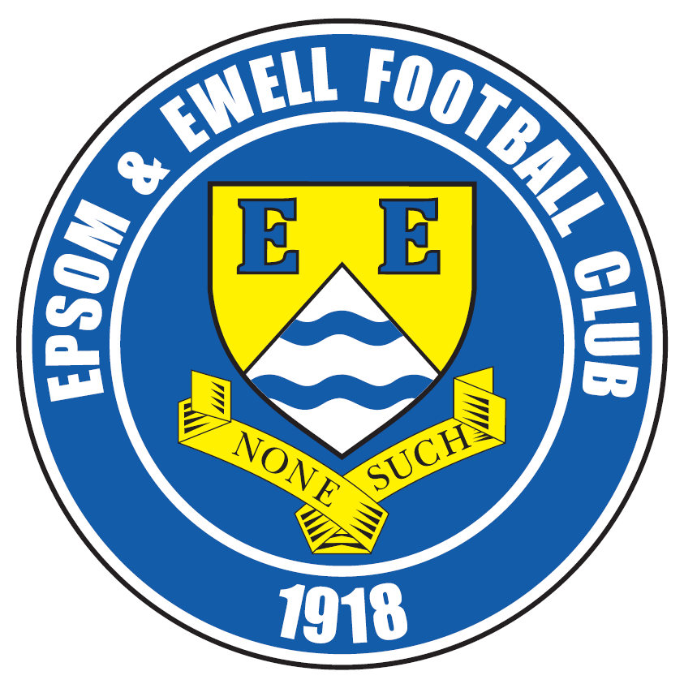 | Epsom & Ewell F.C.  18  v  Hartley Wintney  Saturday, 21st February 2015
For our League match this afternoon we welcome the players and officials of Hartley Wintney F.C. along with today's match officials and of course our own regular supporters.

Our opponents have maintained their form from last season and sit in a healthy position in the League. They are no longer one of the “new boys” looking over their shoulder at the relegation places and are very much an established Premier Division club these days.

We lost 2-1 at Green Lane in August and it was one of the best performances against us this season in my opinion. We will be in for an equally tough game today, although it is hoped that Michael Eacott will have a quieter day than he had over there!

Our run of tough fixtures is unforgiving. We have not met a team outside the top ten since 8th November and with our meeting today, will now have met every single team above us in that period, whilst facing none of the others, excepting Frimley Green in a League Cup tie! It shows no signs of ending as we face arguably the best three teams in the league in our next four games. When you throw in our four suspensions, now finally all cleared, it was almost inevitable that we would drop a little in the League table, although that is also down to having played just one League match since 17th January.

Looking back it was actually a good time for George Murphy to have his double hernia operation as it looks like he will miss very few games before he is ready to go again. Apart from George, this is the first match where to my knowledge we have everyone else available, so you might say that our season starts here.

We last played a fortnight ago when we subsided to a three goal half time deficit against leaders Camberley. However, we showed character to fight back and “win” the second half 2-1 so we know we can compete against the top sides and have to start showing that today, and then here against Camberley on Tuesday in the League Cup Quarter Final. We then travel to Molesey on Saturday before returning for two more home League games; midweek against Hanworth Villa and then Cove. All of these are of course vulnerable to our unsettled weather at present, so please keep checking the website and twitter for up to date details.

We are urgently looking for match and player sponsors, please get in touch! Also, the Salts Super Six Predictor jackpot is now up to £239 just for getting six results right. How much larger can that prize get?

Thanks for watching today. Glyn, the lads and the club value your support.

Rich

Cover photo this week by Gemma Jarman

Alex McGregor fires in the opening goal in our 4-2 win
over Hartley Wintney here last season


Cherry Red Records
Combined Counties League
Premier Division Table 2014/15
inc Wednesday  18th February 2015 | P | W | D | L | F | A | Pts | GD | H | A
Cove | 29 | 20 | 5 | 4 | 72 | 45 | 65 | +27 | 7/3 | 0-1
Camberley Town | 27 | 20 | 4 | 3 | 67 | 21 | 64 | +46 | 2-4 | 0-1
Ashford Town (Mx) | 28 | 19 | 2 | 7 | 69 | 34 | 59 | +35 | 2-4 | 3-1
Molesey | 25 | 19 | 0 | 6 | 76 | 25 | 57 | +51 | 1-3 | 28/2
Windsor | 29 | 17 | 4 | 8 | 69 | 39 | 55 | +30 | 0-5 | 11/4
Spelthorne Sports | 28 | 15 | 3 | 10 | 57 | 47 | 48 | +10 | 4-3 | 3-0
Hartley Wintney | 28 | 13 | 4 | 11 | 39 | 49 | 43 | -10 | 21/2 | 1-2
Badshot Lea | 27 | 12 | 5 | 10 | 56 | 45 | 41 | +11 | 21/3 | 2-4
Farnham Town | 28 | 12 | 5 | 11 | 64 | 64 | 41 | 0 | 2-4 | 2-0
Bedfont Sports | 27 | 12 | 3 | 12 | 44 | 48 | 39 | -4 | 0-1 | 2-0
Colliers Wood United | 29 | 11 | 2 | 15 | 51 | 53 | 36 | -2 | 4/4 | 2-3
Mole Valley SCR | 28 | 10 | 5 | 13 | 50 | 69 | 35 | -19 | 1-0 | 5-2
Epsom & Ewell | 26 | 10 | 2 | 14 | 48 | 51 | 32 | -3 | - | -
Chertsey Town | 29 | 9 | 4 | 16 | 45 | 64 | 31 | -19 | 1-2 | 14/3
Raynes Park Vale | 25 | 8 | 5 | 12 | 34 | 44 | 29 | -10 | 0-1 | 10/3
Knaphill | 27 | 8 | 5 | 14 | 35 | 60 | 29 | -25 | 18/4 | 4-1
Westfield | 25 | 7 | 5 | 13 | 37 | 49 | 26 | -12 | 24/3 | 0-4
Horley Town | 27 | 6 | 6 | 15 | 50 | 73 | 24 | -23 | 2-2 | 6/4
Guildford City | 26 | 6 | 3 | 17 | 44 | 76 | 21 | -32 | 4-1 | 28/3
Hanworth Villa | 25 | 5 | 5 | 15 | 33 | 52 | 20 | -19 | 3/3 | 5-2
Frimley Green | 27 | 5 | 4 | 18 | 44 | 76 | 19 | -32 | 0-0 | 25/4

Lucky Day? – 21st February
Played 16 - Won 6 Drawn 4 Lost 6 - F 26 A 27 - PPG 1.38 - Average
Club record against Hartley Wintney
Played 7 - Won 3 Drawn 2 Lost 2 - F 20 A 12 - PPG 1.57 - Above Average
Last visit
Tuesday 4th February 2014 - Won 4-2 - Combined Counties League

First Eleven Appearances - (max 34 inc Camberley Town)
Name | Debut | 2014/15 |  |  |  | Career Totals
Name | Debut | App | Sub | Total | Goals | App | Sub | Total | Goals
BROWN Oshane* | 30/08/2014 | 2 | 0 | 2 | 0 | 2 | 0 | 2 | 0
BURNS Robbie | 14/08/2007 | 1 | 1 | 2 | 0 | 203 | 15 | 218 | 121
COOPER-SMITH Daryl | 03/01/2015 | 4 | 1 | 5 | 2 | 4 | 1 | 5 | 2
CURRIE Sam | 04/08/2012 | 2 | 3 | 5 | 0 | 96 | 8 | 104 | 2
DEAN Dan | 02/08/2014 | 25 | 1 | 26 | 0 | 25 | 1 | 26 | 0
DEWAR Ali | 29/10/2011 | 5 | 6 | 11 | 3 | 55 | 35 | 90 | 10
DOUGLIN Karl* | 03/08/2013 | 1 | 0 | 1 | 1 | 41 | 3 | 44 | 14
DOWNS Carl* | 17/09/2011 | 4 | 1 | 5 | 0 | 94 | 13 | 107 | 2
EACOTT Michael | 02/08/2014 | 32 | 0 | 32 | 0 | 32 | 0 | 32 | 0
FARRELL Matt | 02/08/2014 | 29 | 3 | 32 | 3 | 29 | 3 | 32 | 3
FERDINANDO Matt | 20/09/2014 | 17 | 3 | 20 | 6 | 17 | 3 | 20 | 6
GAFFNEY Luke* | 16/08/2014 | 10 | 1 | 11 | 0 | 10 | 1 | 11 | 0
HARPER Tommy* | 15/04/2014 | 1 | 0 | 1 | 0 | 2 | 1 | 3 | 0
HAYWARD Ben | 07/03/2007 | 6 | 0 | 6 | 0 | 242 | 28 | 270 | 18
HOADLEY Harry* | 27/08/2011 | 6 | 1 | 7 | 0 | 7 | 1 | 8 | 0
HOUGH Kyle | 14/08/2007 | 28 | 2 | 30 | 16 | 282 | 14 | 296 | 153
JARMAN Mark* | 08/08/2009 | 5 | 5 | 10 | 0 | 136 | 51 | 187 | 76
MARVELL Dale* | 15/01/2000 | 11 | 5 | 16 | 5 | 261 | 45 | 306 | 85
MCGREGOR Alex | 08/08/2009 | 12 | 0 | 12 | 1 | 169 | 54 | 223 | 27
MCKAY Alex | 20/12/2008 | 8 | 4 | 12 | 1 | 73 | 26 | 99 | 8
MURPHY George | 28/03/2013 | 22 | 1 | 23 | 1 | 63 | 5 | 68 | 3
MUTIMA Lionel* | 05/08/2014 | 4 | 2 | 6 | 0 | 4 | 2 | 6 | 0
NELMES Elliott* | 05/08/2014 | 2 | 0 | 2 | 0 | 2 | 0 | 2 | 0
PANAYI Anthony | 14/11/2010 | 26 | 1 | 27 | 0 | 153 | 15 | 168 | 4
PANAYIOUTOU Savva | 03/01/2015 | 5 | 0 | 5 | 1 | 5 | 0 | 5 | 1
ROBINSON Matt | 01/12/2012 | 16 | 1 | 17 | 3 | 17 | 4 | 21 | 4
ROBINSON Sam | 22/10/2011 | 18 | 1 | 19 | 6 | 42 | 4 | 46 | 11
ROWE Steve | 27/08/2011 | 8 | 0 | 8 | 0 | 13 | 1 | 14 | 0
SHAW Ollie | 20/09/2014 | 0 | 10 | 10 | 0 | 0 | 10 | 10 | 0
SMITH Matt | 08/08/2009 | 0 | 1 | 1 | 0 | 91 | 43 | 134 | 10
SMITH Taylor* | 02/08/2014 | 13 | 2 | 15 | 7 | 13 | 2 | 15 | 7
TANTON Matt | 02/08/2014 | 18 | 4 | 22 | 1 | 18 | 4 | 22 | 1
TAYLOR James | 26/08/2013 | 27 | 1 | 28 | 2 | 44 | 7 | 51 | 3
VAN GELDER Julian* | 12/09/2006 | 0 | 1 | 1 | 0 | 0 | 2 | 2 | 0
WHITE Sean* | 02/08/2014 | 6 | 13 | 19 | 3 | 6 | 13 | 19 | 3
Own Goal |  |  |  |  | 1
* Player has left the club

Results and Fixtures
Combined Counties League – Saturday 7th February
Ashford Town (Mx) | 5-1 | Hartley Wintney
Badshot Lea | 0-0 | Spelthorne Sports
Chertsey Town | 1-2 | Bedfont Sports
Colliers Wood United | 2-1 | Knaphill
Cove | 3-1 | Mole Valley SCR
Epsom & Ewell | 2-4 | Camberley Town
Farnham Town | 4-3 | Molesey
Guildford City | 3-3 | Horley Town
Windsor | 1-2 | Westfield
Combined Counties League Cup Third Round – Tuesday 10th February
Westfield | 2-3+ | Cove
Combined Counties League – Tuesday 10th February
Chertsey Town | 2-2 | Colliers Wood United
Farnham Town | 0-1 | Raynes Park Vale
Combined Counties League – Wednesday 11th February
Guildford City | 2-1 | Knaphill
Combined Counties League – Saturday 14th February
Camberley Town | 2-2 | Windsor
Cove | 5-2 | Chertsey Town
Hanworth Villa | 2-1 | Colliers Wood United
Hartley Wintney | 2-3 | Bedfont Sports
Spelthorne Sports | 1-5 | Farnham Town
Surrey Senior Cup Q-F – Tuesday 17th February
Ashford Town (Mx) | 3-1 | Westfield
Combined Counties League – Tuesday 17th February
Bedfont Sports | 6-0 | Mole Valley SCR
Knaphill | 3-0 | Spelthorne Sports
Surrey Senior Cup Q-F – Tuesday 17th February
Colliers Wood United | 0-2 | Merstham
Combined Counties League – Wednesday 18th February
Guildford City | 1-5 | Molesey
Combined Counties League – Saturday 21st February
Bedfont Sports | V | Cove
Chertsey Town | V | Hanworth Villa
Colliers Wood United | V | Molesey
Epsom & Ewell | V | Hartley Wintney
Results and Fixtures
Combined Counties League – Saturday 21st February
Frimley Green | V | Camberley Town
Horley Town | V | Badshot Lea
Mole Valley SCR | V | Ashford Town (Mx)
Guildford City | V | Farnham Town
Spelthorne Sports | V | Raynes Park Vale
Windsor | V | Knaphill
Combined Counties League Cup Q-F – Tuesday 24th February
Epsom & Ewell | V | Camberley Town
Combined Counties League – Tuesday 24th February
Farnham Town | V | Ashford Town (Mx)
Hartley Wintney | V | Guildford City
Knaphill | V | Frimley Green
Raynes Park Vale | V | Molesey
Westfield | V | Bedfont Sports
Combined Counties League Cup Q-F – Wednesday 25th February
Colliers Wood United | V | Badshot Lea

Congratulations Alex!
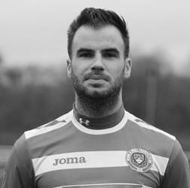
Assuming he is selected, Alex McKay will make his 100th appearance for the club today, becoming the 115th player in club history to reach that mark.

That might sound like a lot of players but as we have been a Senior club for just 91 seasons, it is only just over one player a year, so is a significant achievement.

Alex has been with us, on and off, for quite a while now, actually making his debut way back on 20th December 2008 for our top two battle at Merland Rise against eventual Champions Bedfont Green.

He has proven to be quite adaptable, often playing in front of the back four instead of being part of it, and I recall one game at South Park, where it just looked as though they wouldn’t get though, as he was protecting our boys so well.

His “footballing CV” has grown this season as he is now one of our Player / Coaches at the club and in November he qualified as a referee. In tribute to his qualification, he then travelled all the way over to Molesey for our League match, instead of coming to Chipstead, as we were actually playing at home!!

Congratulations Alex!

From behind the goal
Epsom & Ewell 2-4 Camberley Town
Combined Counties League - Saturday 7th February 2015

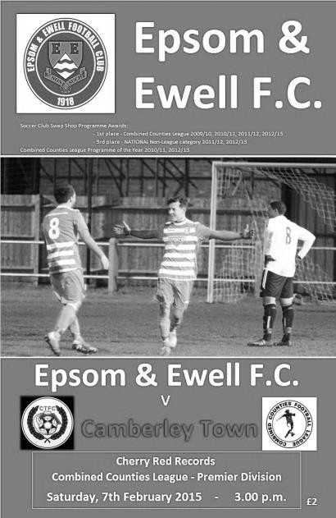
Salts unable to dent Krooners unbeaten run

Two months ago I wrote that both Epsom and Ewell and Camberley Town were unlikely to gain promotion, based on the fact that we were some way adrift of Cove and Ashford Town. This clearly made sense at the time, although since then our opponents have put together a winning run that enables them to sit at the top of the table with every chance of the League title.

For our part, by the time we got into any sort of form or fluency we already faced a three goal deficit and any chance of rescuing anything from the game was virtually gone. As it turned out we nearly did pull a rabbit out of the hat as two second half goals, coupled with a sending off for the Camberley striker James Hubbard gave us a bit of hope for a few minutes before a defensive error finally confirmed all three points for the visitors.

The first twenty minutes were fairly non-descript with exception of a chance for the Krooners in just the second minute when a high ball in was met by a volley from Hubbard at full stretch which beat the advancing Michael Eacott but the ball was cleared off the line by the retreating and well-positioned Alex McKay. In response Alex McGregor then had a decent chance when put through by Agi Panayiotou but he had more time than he realised and snatched at his shot from the edge of the area.

The visitors began to press us back more from that stage and a ball over the top of James Taylor landed perfectly in stride for Hubbard but Eacott blocked his shot well with his legs. Unfortunately, from that corner they then took the lead as a low delivery was missed by everyone as it fizzed across the goalmouth and Hubbard was there to fire home at the far post in the 21st minute. Worse was to come less than 60 seconds later when a ball in was met by a looping header from Bunyan which dropped over the exposed Eacott and into the net.

We tried to respond but our only other real chance of the half came in the 40th minute when Panayiotou set up Matt Ferdinando with a sight of goal, but he was at an angle and in attempting to go for the roof of the net he struck his shot just over the bar.

Unfortunately, insult was added to injury when Camberley then scored their third goal on the break, and although it was hard to see exactly who was at fault for the goal, it's fair to say it wasn't our finest hour and Coles finished off easily.

The second half started well for the Salts. A bit of early pressure pushed Camberley back, and in the 49th minute a defensive pass was intercepted by former Krooner Robbie Burns, making his first start since returning to our club. He held the ball up before releasing it to Matt Robinson who had found space well and he had time to kill the ball, cut back and then stroked it into the corner of the net, beating the defenders that had by then got back to the goal line.

Our chances of an unlikely salvage mission were enhanced further when visiting striker Hubbard received a red card for a challenge that was late, although from the distance I was at, it was difficult to judge whether there was any more in it than just a foul. I suppose it was similar in nature to the card that Dan Dean received against Windsor. Having said that, you wouldn't have known they were a man short as we couldn't get out of our half for the next ten minutes! One occasion was particularly scary when a ball across from the left was met at the far post by a striker who appeared to have the freedom of the park, but Eacott did really well to block the chance.

Gradually we got back into the match and McKay was unfortunate to see his powerful long range strike deflected just wide of the far post but after 78 minutes we were back in the game when substitute Daryl Cooper-Smith was in the right place to volley home a pinpoint Steve Rowe cross from the left flank. Regrettably two minutes later the chance had gone again as a defensive miscommunication enabled Greenwood to stick a leg out, reaching the ball ahead of Eacott and guide the ball slowly into the net in the 80th minute.

We had one final chance when Cooper-Smith headed a Rowe free kick just beyond the top corner in injury time, but ultimately we were beaten as much by our own errors as by the opposition, although they took full advantage of those mistakes and showed why they are now favourites for the title.

For our part, we are now suspension free for the first time in months and with the returning Sam Robinson and Dan Dean, together with the absent Kyle Hough, and the back to full fitness Sam Currie, our Manager will finally have plenty of selection options as we prepare for the trip to Raynes Park Vale next weekend.

Team: Michael Eacott, James Taylor, Steve Rowe, Anthony Panayi ©, Alex McKay, Savva Panayiotou, Matt Robinson, Matt Farrell, Robbie Burns, Alex McGregor, Matt Ferdinando

Subs: Daryl Cooper-Smith for McGregor (68), Sam Currie for Ferdinando (94)

Club Records - 21st February
Date | Day | Competition |  | Opponents |  | Scorers
21/02/25 | Sat | Surrey Senior League | H | Farnham United Breweries | 0-2
21/02/31 | Sat | London League | H | Romford | 3-3 | o.g., R.Marlow, G.Prestoe
21/02/48 | Sat | London League | A | Leavesden | 2-3 | B.Peacock, J.Stackhouse
21/02/53 | Sat | Surrey Senior Shield 1 | A | Leatherhead | 2-0 | I.Hughes (2)
21/02/59 | Sat | Corinthian League | A | Eastbourne | 0-0
21/02/70 | Sat | Athenian League 2 | H | Uxbridge | 0-4
21/02/81 | Sat | Isthmian League 1 | A | Chesham United | 1-0 | M.Cornwell
21/02/84 | Tue | Isthmian League 1 | A | Leatherhead | 1-2 | A.Morton
21/02/85 | Thur | London Senior Cup 2 | A | Walthamstow Avenue | 3-2 | T.Tuite (3)
21/02/87 | Sat | Isthmian League 1 | A | Finchley | 2-1 | J.Rains, J.Richardson (pen)
21/02/89 | Tue | Surrey Senior Cup SF | H | Carshalton Athletic | 2-2 | C.Hadingham, B.Perkins
21/02/95 | Tue | Isthmian League 3 | H | Cove | 5-1 | P.Meredith (2), S.Miller, K.Webb, o.g.
21/02/98 | Sat | Isthmian League 3 | A | Flackwell Heath | 3-0 | K.Webb (2), A.Boxall
21/02/04 | Sat | Isthmian League 1s | H | Dulwich Hamlet | 0-2
21/02/07 | Wed | Combined Counties  Premier Division | A | Colliers Wood United | 0-3
21/02/09 | Sat | Combined Counties  Premier Division | A | Bedfont | 2-2 | K.Hough (2)
Historical Decades
90 years ago – Epsom Town
21/02/25 | Sat | Surrey Senior League | H | Farnham United Breweries | 0-2
80 years ago – Epsom F.C.
23/02/35 | Sat | London League | H | Finchley | 2-1 | J.Jones, G.Collins
70 years ago – War time Epsom Town
17/02/45 | Sat | South Eastern  Combination | A | London Fire Force | 4-3 | C.Cairns (2), S.Weller, ?.Box
60 years ago – Epsom F.C.
19/02/55 | Sat | Surrey Senior Shield 1 | H | McLaren Sports | 3-0 | D.Muirhead, L.Peake, G.Hurst
50 years ago – Epsom & Ewell
13/02/65 | Sat | Athenian League 1 | H | Wokingham Town | 2-2 | B.Mackay, C.O'Mahoney
40 years ago – Epsom & Ewell
22/02/75 | Sat | Surrey Senior League  Charity Cup 2 | A | Whyteleafe | 1-0 | P.Walker
30 years ago – Epsom & Ewell
21/02/85 | Thur | London Senior Cup 2 | A | Walthamstow Avenue | 3-2 | T.Tuite (3)
20 years ago – Epsom & Ewell
21/02/95 | Tue | Isthmian League 3 | H | Cove | 5-1 | P.Meredith (2), S.Miller, K.Webb, o.g.
10 years ago – Epsom & Ewell
19/02/05 | Sat | Isthmian League 2 | A | Edgware Town | 1-3 | L.Purvis

History Corner - 21st February
90 years ago today Champions elect Farnham United Breweries visited the Horton Hospital Grounds for a Surrey Senior League match. In just our third game as a Senior club we had gone there and won 4-0 to announce ourselves on the stage, but over the season, dropped points here or there ensured that we were only to finish third and two first half goals for the visitors saw them on their way to repeating their League and Cup double of the previous season.

70 years ago this week our war time Epsom Town side met the London Fire Force in a South Eastern Combination League match. In a match played at Champion Hill as the Fire Force were unable to use their ground on the day, we trailed 2-0 after ten minutes but recovered to win the match 4-3 and record a very rare win at the Dulwich ground.

67 years ago today we travelled up to snowy Leavesden where the game was one of the very few played in the South East that day. Whether it was because of our previous club record 14-0 defeat at Chelmsford City on our last visit, or whether it was due to the weather, but only eight players made the journey. Quick thinking Secretary Harry Hawke signed up three players from the crowd, one of whom had played pre-war for Leavesden against us and we then proceeded to give the hosts a good game. With the score at 2-2 in the final minute we had a goal harshly disallowed and Leavesden went straight up the other end and scored to win the match 3-2. Gutted!

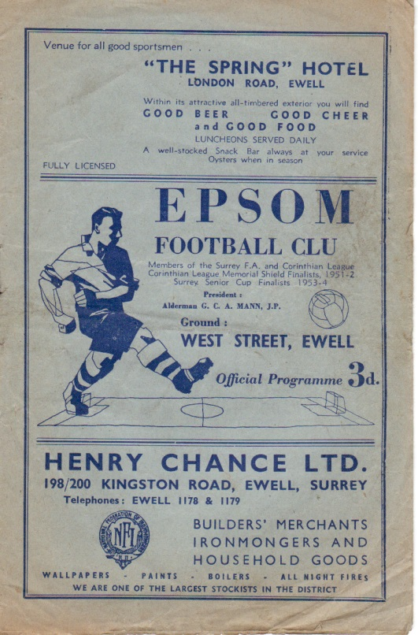
60 years ago this week we hosted and defeated McLaren Sports by three clear goals at West Street. This was a first round Surrey Senior Shield match and wins over Camberley Town and then Carshalton Athletic earned us the Shield for the second time in our history, despite both our First team and Reserves finishing bottom of the Corinthian League that season!
(see programme right)

30 years ago today Tommy Tuite scored a hat trick as we defeated Walthamstow Avenue in the London Senior Cup by three goals to two. The game was only just on, as poor weather ensured a late decision on the game and in these pre-twitter and mobile phone days I recall having to get all the way up there by train, not knowing whether it would still be on until I arrived! I’m glad I went!

Hartley Wintney - History
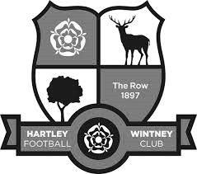
Hartley Wintney Football Club, as our records indicate, was founded in 1897 and played in an area situated at Causeway Farm, not far from our present headquarters and adjacent to the village's golf and cricket clubs. From stories told by the older members, and from the old club records, it appears that the village side competed well against local opposition, despite the facilities not being of today's standard, with only a horse trough or the pond to remove the heavy mud from a sub-standard pitch. In 1953, the club moved to its present ground in Green Lane, known as 'The Memorial Ground'. A pavilion was erected and the team played in the Basingstoke and Aldershot Leagues.

In 1973, Glynn Howells (a former Epsom & Ewell goalkeeper and father of Tottenham player David Howells) was appointed Manager and, with an influx of players, Hartley Wintney FC was put firmly on the local football map. In his six year reign, the team managed to win the Aldershot Senior League three times in succession and, on a night to remember, the Aldershot Senior Cup. In 1975, the facilities were once again improved, when a bar was built within the pavilion.

After several seasons in the ASL, Hartley applied for the Combined Counties League - a competition that replaced the Surrey Senior League - and were granted admittance. After the first couple of seasons and two changes of management, the club appointed Ian Bedford as Manager. Once again an influx of senior players gave Hartley the success they deserved. Within his three years in management, they gained trophies including the League Title (1982-1983) and Runners Up (1981-1982), Aldershot Senior Cup Winners (1980-1981), George Allen Cup Winners (1981-1982). They were also Runners Up in the League Cup (1982-1983) and Aldershot Senior Cup (1981-1982).

During this period a new Club House, which is our present H.Q., was opened by ex-Chelsea star Peter Osgood. These facilities, together with the recently improved dressing rooms, are ranked as amongst the very best in the League. David Willoughby, the then Secretary/Treasurer, and Bill Mitchell, Chairman, spent exceptional hours in the embryo stages of this venture - one of the bars is now named 'The David Willoughby Room'.

Hartley Wintney FC has come a long way, from village side in every sense of the term, to today's 7 days a week modern Football Club, but it’s hard working committee has succeeded in retaining a village atmosphere. In recent years, the club has invested in new floodlights costing £40,000, completely rebuilt the changing rooms at a cost of over £100,000, and erected a modern stand with seating. The Club is indebted to the volunteer workers who continue to keep the Club afloat.

The club gained promotion from Division One of the Combined Counties League in 2007-08. But 08/09 began poorly and ended in relegation by a narrow margin. The 2011-12 season under manager Neville Roach, Assistant Mick Wollen and Coach Scott Tarr was a notable one for the club as they again achieved promotion back to the Combined Counties League Premier Division and also had a fine F.A. Cup run that took them to the third qualifying round, going out in the Third Qualifying Round at Conference South near neighbours Basingstoke Town.

The euphoria of the cup run and promotion was dampened at the end of the 2011-12 season when the coaching staff left to take the managerial role at Southern League Thatcham Town. The entire squad bar two players left, and so new manager Dave Tuttle was faced with the huge task of rebuilding a squad competitive enough for the CCL Premier. A reasonably good squad was assembled, but events behind the scenes and within the playing squad added to the pressure following a string of poor results. It led to a second change in the management setup of the first team in less than 4 months, with 24 year-old Ben Dillon given his first managerial position.

Jason Minton became Ben's Assistant, with Joe Lawler also joining as coach, and once again there was an almost total outflow of the players Dave Tuttle had brought to the club. Ben and Jason thus had to set about again rebuilding the squad, but by this time with Hartley well and truly set adrift at the bottom of the league and the season in full flow. Clearly something of a baptism of fire for the young managerial partnership, but their enthusiasm, belief and the introduction of a talented group of new players quickly restored the spirit around the whole club. Hartley Wintney's place in the CCL Premier was secured after a truly remarkable second half of the season thanks to the belief and commitment of the new squad and the coaching staff and in 2013/14 they reached the F.A. Cup fourth qualifying round, losing at home to Southern League Daventry Town.

The football club has established a clear line of progression for young players with the establishment of an U18 Youth setup playing in the Southern Youth League, and a Reserve team playing in the Suburban League. The senior club has also moved to improve links with the Junior club. These factors are huge positives which the committee hopes will greatly improve the club's chances of continuing to play and maintain their position at an elevated level of amateur football.

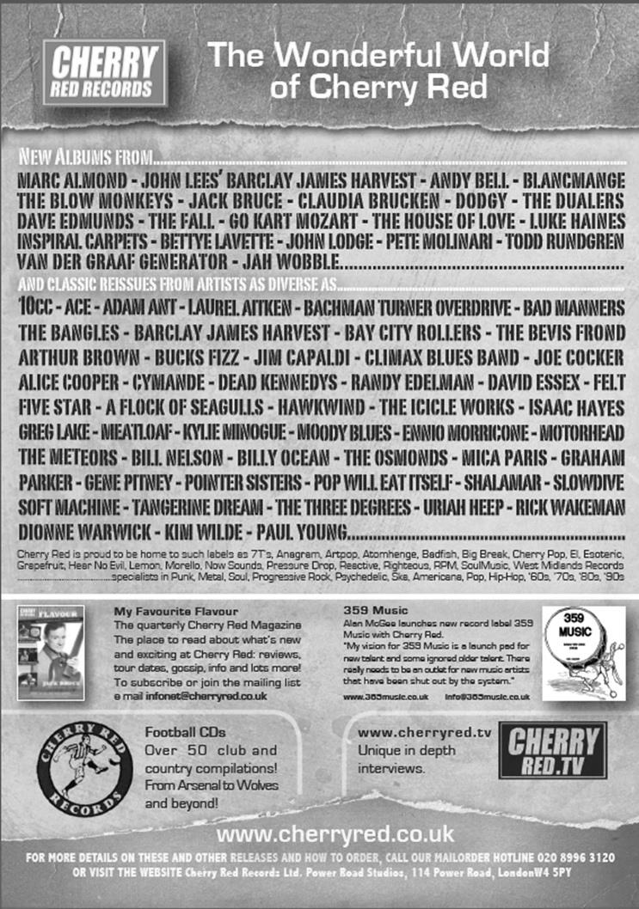
Centre page for results

Centre page for results



EL Records Premier Challenge Cup
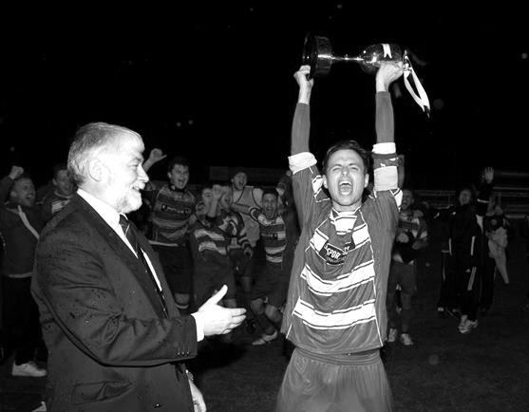
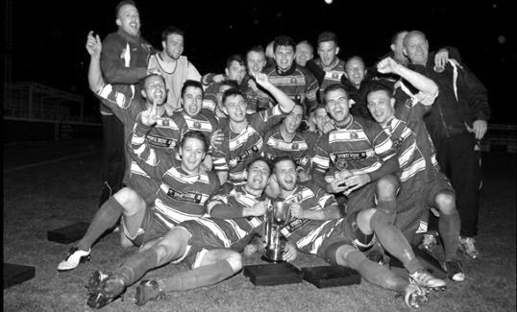
Second Round
Alton Town | 1-4 | Farnham Town
Ashford Town (Mx) | 5-0 | CB Hounslow United
Badshot Lea | 10-2 | Dorking
Bedfont Sports | 1-1+ | Cove
Cove won 4-1 on penalties
Camberley Town | 0-0+ | Molesey
Camberley Town won 3-0 on penalties
Chertsey Town | 0-7 | Windsor
Cobham | w/o Horley | Horley Town
Colliers Wood United | 3-0 | Bedfont & Feltham
Epsom & Ewell | 2-1 | Knaphill
Epsom Athletic | 0-5 | Banstead Athletic
Eversley & California | 2-4 | Ash United
Frimley Green | 1-0+ | Spelthorne Sports
Hanworth Villa | 2-3 | Guildford City
Sheerwater | 1-6 | Mole Valley SCR
Westfield | 4-0 | Farleigh Rovers
Worcester Park | 1-0 | Chessington & Hook United
Third Round
Westfield | 2-3+ | Cove
Badshot Lea | 5-0 | Guildford City
Worcester Park | 6-1 | Banstead Athletic
Farnham Town | 2-0 | Mole Valley SCR
Frimley Green | 0-5 | Epsom & Ewell
Windsor | 8-1 | Ash United
Colliers Wood United | 3-2 | Horley Town
Camberley Town | 3-0 | Ashford Town (Mx)
Quarter Finals
Colliers Wood United | 25/2 | Badshot Lea
Worcester Park | 21/3 | Windsor
Epsom & Ewell | 24/2 | Camberley Town
Farnham Town | 3/3 | Cove

Player Sponsorship
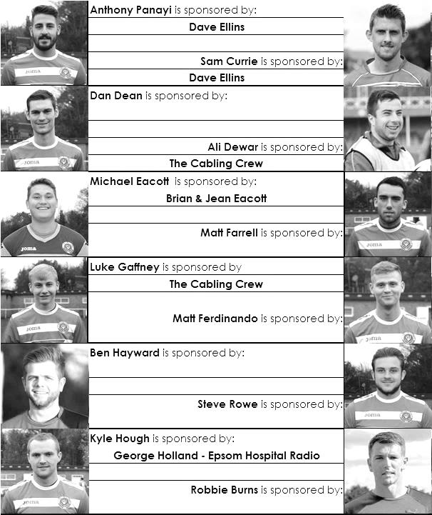

Here is the latest list showing all of the players and Management available for sponsorship. Sponsorship costs just £40 so if you want to help the club, the player and get your name in the programme for the season, let us know before they go!

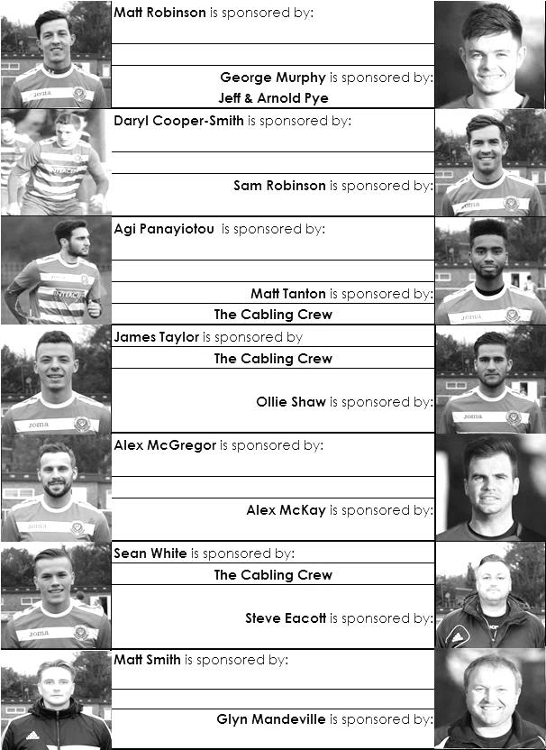

Every Opponent A-Z
Over the years we have played many, many different opponents. Exactly how many is a difficult question, as it all depends on your definition. Are Camberley & Yorktown different to Camberley Town, or are Epsom Town different to Epsom F.C. or Epsom & Ewell F.C.?

In my analysis I have classed them as the same team, and will work through them all from A to Z. Some we have played many times, whilst others we have met maybe just once or twice. Enjoy!


Metrogas: Played 1 - W1 D0 L0 - F6 A0 - PPG - 3.00 - Perfect

Metrogas were, back in the day, a powerful London League works side, representing the South Metropolitan Gas Company; the nation’s second largest back in Victorian and Edwardian times. Their main base was on the Old Kent Road and we went there for a friendly over ninety years ago on 11th October 1924, winning 6-0 with Reg Marlow scoring the first of what would become twenty-eight hat tricks for our club.

We were technically a level lower than them in the Surrey Senior League even though they were struggling, and by the time we arrived in the London League in 1927 they had dropped out, playing in minor competitions like the London Business Houses League. They do currently still exist, playing at Step Six as members of the Kent County League in Step Six football and are nowadays based in Eltham.

Millwall United: Played 4 - W3 D1 L0 - F14 A7 - PPG - 2.50 - Fantastic

First things first, there is no connection between this club and the much better known Millwall that exist today. They played at the Lockes Sports Ground from 1922, although I have been unable to confirm whether or not they were still there by the time we met them in London League battles from 1927, although before we met in League action, we hosted them in a friendly, winning 4-3 at West Street in August 1926, a game noted also for the debut of George Mackesy, who would become the longest serving Captain in our history. These were official matches back then, as what we know as friendlies today were seen as “trial matches”.

We met for the first time when we travelled there on 31st March 1928, winning 2-0 thanks to goals from our main strikers of the day, Reg Marlow and the ill-fated Jack Parr. This almost clinched the London League title for our boys, although in April we switched off and losses at home to Carshalton Athletic and Grays Athletic meant that we needed to win our final two games to be certain. Although much press is given to our 2-1 win at Grays to clinch the title on the final day, it would not have been possible if we hadn’t won 7-3 at home to Millwall United three days earlier when Herbert Etheridge scored a hat trick in our demolition of the London side.

We visited them very early in the 1928/29 season; Saturday 8th September, to be precise, where we drew 1-1, Jack Parr again scoring, although this equaliser fifteen minutes from time was hotly disputed by the home side who felt that the ball hadn’t crossed the line. Either way, it didn’t matter at all, as they withdrew from the League in December 1928 and their results were removed from the table that season. Did they lose their ground? If so it was very sudden and it is more likely that they just ran out of players or administrators as happened more frequently back then. It must have been extremely difficult trying to operate successfully with such a big club nearby.

Milton United: Played 1 - W1 D1 L0 - F3 A0 - PPG - 3.00 - Perfect

This meeting was a lot more recent than the others so far today as we hosted Milton United in the F.A. Vase back in 2005 as a result of a win over Petersfield Town. They travelled to Merland Rise where two goals from Luke Gay added to the opener from Dale Marvell as we triumphed 3-0. However, a three week layoff coupled with a broken leg in Sunday football for our keeper Alex Moore meant that we came back from our break rusty; losing at Kingsbury and a week later we lost our next match in the Vase embarrassingly at Herne Bay, so the win counted for nothing in the end!

Milton United were a Hellenic League side at the time and remain so to this day.
Mitcham Wanderers: held over to next week

Mole Valley SCR: Played 8 - W6 D1 L1 - F22 A10 - PPG - 2.38 - Fantastic

We now go right up to date with a current opponent. Mole Valley SCR had a nomadic history during their near forty year existence. As a Sunday side they made great strides in local football before deciding to take the step up into the pyramid. The SCR tag was their full name for many years as an indication of their roots (Sutton Common Rovers). Then, as now, the driving force was their Chairman Alan Salmon and from 2004 Mole Valley SCR as they were then known started their climb up the leagues, reaching our League in 2008 via the unusual route of the Middlesex County League.

By this time they were playing as tenants of Cobham F.C. and moved up to the Premier Division for 2010/11 season, where we first met, on Saturday 21st August 2010 at our new temporary home of Merstham’s Moatside ground. A late goal looked to have given us the points but an equaliser from their talisman striker Jay Holden secured a point and they defeated us 4-1 at Cobham in late April of that season. What they wouldn’t have realised at the time was that they wouldn’t take another point of us in the next six meetings, all of which have gone our way. Holden also came to us for a brief spell the following season but returned a couple of months later.

They started badly in 2011/12 and despite improving towards the end, couldn’t get out of trouble, being relegated along with Banstead Athletic. However, they bounced straight back after a slow start and finished well, being assisted by Phil Page, another striker who has strong links there, despite regularly playing for Farnborough F.C. in Step Two. Now back in the Premier Division, they survived last season, despite 3-0 and 4-0 wins for us and this term they have settled into a midtable position, again, despite a 1-0 defeat at Chipstead and our 5-2 win over in Cobham in November.

We share similarities with them as they are also homeless, despite having a small base at Hannibal Way, Wallington where their minor sides operate. The trek to Cobham is a large one and it is interesting to see that they have adopted a name change for next season, removing the Mole Valley tag and reverting to Sutton Common Rovers. The future is uncertain right now, but in terms of playing status, SCR, like today’s opponents Hartley Wintney appear established at this level now.

Surrey Senior Cup
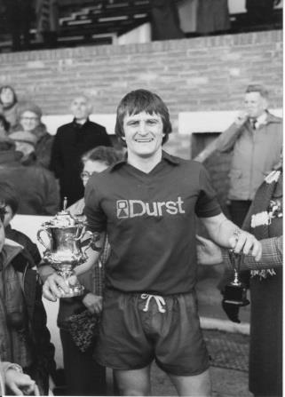
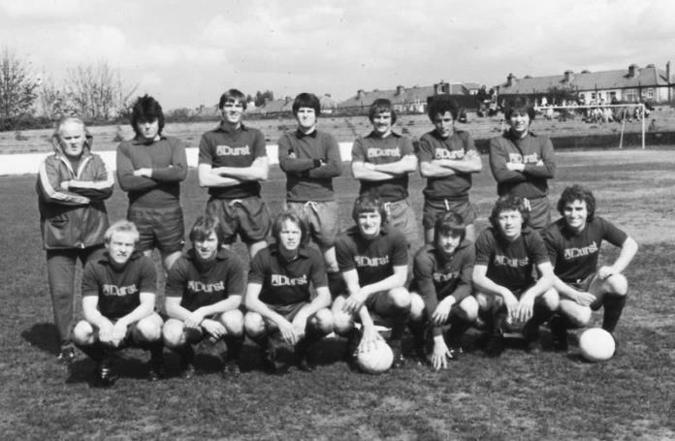
Second Round
Lingfield | 0-1 | Westfield
Redhill | 2-1 | Raynes Park Vale
Played at Raynes Park Vale
AFC Wimbledon | w/o Chipstead | Chipstead
Godalming Town | 2-4 | Mole Valley SCR
Knaphill | 0-3 | Colliers Wood United
Metropolitan Police | 1-0 | Walton & Hersham
Epsom & Ewell | 1-0 | Camberley Town
Leatherhead | 2-1 | Farnham Town
Merstham | 3-1 | Beckenham Town
Molesey | 1-0+ | Egham Town
South Park | 1-4 | Sutton United
Walton Casuals | 1-2 | Corinthian Casuals
Badshot Lea | 2-1 | Kingstonian
Dorking Wanderers | 9-0 | Frimley Green
Tooting & Mitcham United | 2-2+ | Horley Town
Tooting & Mitcham United won 4-2 on penalties
Woking | 0-3 | Ashford Town (Mx)
Third Round
Merstham | 2-1 | Sutton United
Redhill | 0-2 | Westfield
Dorking Wanderers | 3-4 | Colliers Wood United
Molesey | 3-1 | Epsom & Ewell
Leatherhead | 2-3 | Ashford Town (Mx)
Metropolitan Police | 3-0 | Chipstead
Tooting & Mitcham United | 3-1 | Mole Valley SCR
Corinthian Casuals | 1-4 | Badshot Lea
Quarter Finals
Ashford Town (Mx) | 3-1 | Westfield
Colliers Wood United | 0-2 | Merstham
Molesey | V | Badshot Lea
Met Police | 2-1 | Tooting & Mitcham United

F.A. Vase
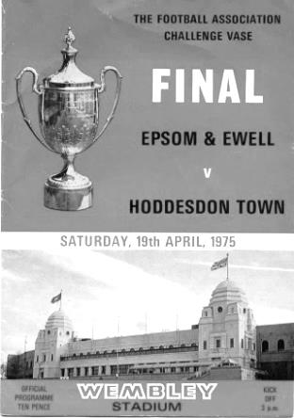
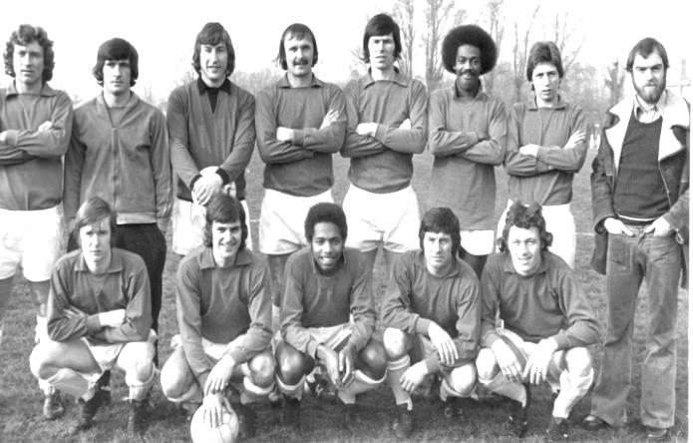
Fifth Round – 7th February
Bradford Town | 0-2 | Highworth Town
AFC St Austell | 2-0 | Stanway Rovers
Ascot United | 3-0 | Norwich United
Shaw Lane Aquaforce | 3-2 | Flackwell Heath
Glossop North End | 2-2+ | Dunston UTS
replaying today in Dunston
Holbeach United | 2-3+ | Erith & Belvedere
North Shields | 4-1 | Phoenix Sports
AFC Mansfield | 0-3 | Tadcaster Albion
Quarter Final Draw – 28th February
AFC St Austell | V | Ascot United
South Western Peninsula League |  | Hellenic League
Erith & Belvedere | V | North Shields
Southern Counties East League |  | Northern League
Shaw Lane Aquaforce | V | Glossop NE / Dunston UTS
Northern Counties East League
Highworth Town | V | Tadcaster Albion
Hellenic League |  | Northern Counties East League

Did You Know?
Both Epsom & Ewell and Hartley Wintney could be excused for having one eye on the F.A. Vase draw on Saturday. We will be watching out for Ascot United, as they contain our former long serving Captain Alex Rodrigues, while Hartley Wintney will be thinking of what could have been, as they were edged out 2-1 in extra time by Highworth Town way back in the qualifying rounds!

Match and Ball Sponsorships – 2014/15
Opponent | Date | Match Sponsor | Ball Sponsor
Raynes Park Vale | 05/08/14 | Club President - Stella Lamont
Horley Town | 25/08/14 | EEFC Management Committee
Croydon (FAC) | 30/08/14 | EEFC Media Officer - Richard Lambert
Frimley Green | 13/09/14 | Dave Gaffney and friends
Guildford City | 30/09/14 | The Jarman family
Mole Valley SCR | 07/10/14 | Mark and Carmel Murphy
Bedfont Sports | 11/10/14 | Epsom & Ewell F.C. Colts
Knaphill (LC) | 14/10/14 | Geoff and Steve Dyke
Ashford Town (Mx) | 18/10/14 | The Building Shop, Bookham
Chertsey Town | 28/10/14 | In Memory of Bob Bexley
Molesey | 22/11/14 | The Cabling Crew 0208 -224 4110
Camberley Town (SSC) | 02/12/14 | In memory of Liz and Doug Burns
Spelthorne Sports | 16/12/14 | long serving supporter Paul Merritt
Windsor | 03/01/15 | Ezara Beddoe
Farnham Town | 17/01/15 | In memory of Chris Henry
Camberley Town | 07/02/15 | Former player Marvin Hough
Hartley Wintney | 21/02/15
Camberley Town (LC) | 24/02/15
Hanworth Villa | 03/03/15
Cove | 07/03/15
Badshot Lea | 21/03/15
Westfield | 24/03/15
Colliers Wood United | 04/04/15
Knaphill | 18/04/15
For League, League Cup and Surrey Senior Cup Matches:

Match sponsorship - £40.00 Match ball sponsorship - £25.00.
Combined Offer of Match and Match Ball sponsorship for £55.00.

For F.A. Cup and F.A. Vase matches:

Match sponsorship - £50.00 Match ball sponsorship - £30.00.
Combined Offer of Match and Match Ball sponsorship for £65.00.
----------------------------------------------------------------------------------------------------------------------------
Sponsorship includes

Admission, programmes, advertising (if required) and hospitality.

If you are interested, just speak to a Committee Member, you know where we are!
Alternatively, drop me an email at: richard.c.lambert@gmail.com

Salts Super Six Predictor
The Salts Super Six Predictor is live again. The next matches are TODAY and tickets are on sale at today’s game to the left of the gate.

The competition is easy to play and you don’t even have to be at the match! To win, you simply need to predict the results of six matches correctly from the three options, fill in the form and make sure it is back with one of our distributors before the deadline on the ticket. The latest fixtures are shown here.

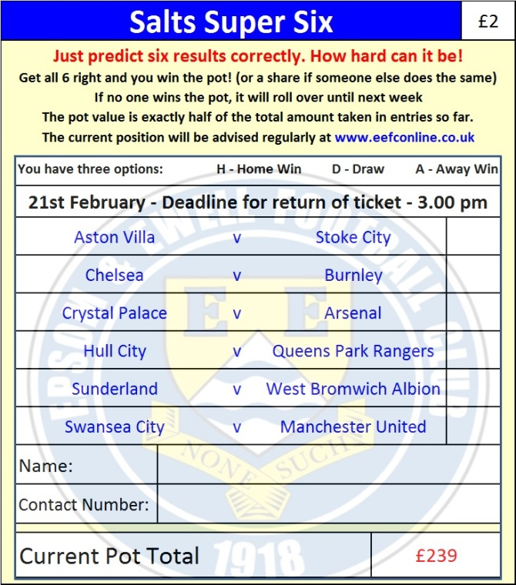
If you are a club regular, you just need to place your name on the sheet, although if you aren’t, then we’ll need a contact number from you too. We will announce any winners on the website within three working days, so don’t worry, we won’t miss you!

The prize pot is currently £239 but will continue to go up, if unclaimed, by the cost of 50% of all the sold tickets. In other words, if we sell 50 tickets at £2 before the deadline, and the pot isn’t won, then the next prize would be £289! You’ll always know the size of the pot before you enter.

Please note that if there is more than one winner, the prize pot would be shared between the winners. All you need to do now is have a go, as many times as you like!

Good luck!

Combined Counties League – Premier Division
Saturday, 21st February 2015 - Kick-off 3.00 p.m.
Epsom and Ewell  (Royal Blue & White hoops) | V |  | Hartley Wintney  (All Orange)
 | NUMBERS
Michael Eacott |  |  | Craig Atkinson
James Taylor |  |  | Tom Walsh
Steve Rowe |  |  | Jason Minton
Anthony Panayi |  |  | Ali Brown
Alex McKay |  |  | Kieran Maylen
Matt Farrell |  |  | Craig Barker
Matt Ferdinando |  |  | Elliot Hobden
Sam Robinson |  |  | Ian Jones
Kyle Hough |  |  | Sam Argent
Alex McGregor |  |  | Shane Hollamby
Matt Robinson |  |  | Lukas Burt
Daryl Cooper-Smith |  |  | Taylor Watts
Dan Dean |  |  | Marc Vockins
Savva ‘Agi’ Panayiotou |  |  | Marc Taylor
Sam Currie |  |  | Jacob Exton
Robbie Burns |  |  | Daniel Brownlie
Ali Dewar
George Murphy
Jamie Hatfield
Ben Hayward
Matt Smith
Matt Tanton
Glyn Mandeville | MANAGER |  | Ben Dillon
Matt Smith | ASSISTANT |  | Dan Brownlie / Joe Lawler
Steve Eacott / Alex McKay | COACHES
Ken Jones | PHYSIO
REFEREE: S.Jack (Aldershot)
ASSISTANTS: R.Wells (Coulsdon), K.Slaughter (Wallington)

OUR NEXT VISITORS TO HIGH ROAD
Camberley Town
Tuesday 24th February 2015 - Kick-off 7.30 p.m.
Combined Counties League Cup – Quarter Final
Please note earlier kick off time to allow for any required extra time or penalties

